8 May, 2024
Notice
Notice/Academic/15/23-24
Dear Parents,
Greetings!
You are cordially invited to attend the Parent-Teacher Meeting on Saturday, 11th May 2024, from 10:00 am to 12:30 pm at DIS, Uttara. Your presence and participation are greatly appreciated.
Please kindly adhere to your designated time slot.
SL No | Time | Session | Venue
1. | 10:00 am to 10:30 am | Introduction and greetings | DIS, Auditorium (3rd Floor)
2. | 10:30 am to 11:00 am | Meet the Principal | DIS, Auditorium (3rd Floor)
3. | 11:00 am to 12:30 pm | Meet the teachers | Respective Class Rooms  Pre-primary: (1st & 2nd Floor)  Grade: 1 to 4 (5th Floor)  Grade: 5 to 8 (6th Floor)  Grade: 9 to 10 (7th Floor)

Thanking you.
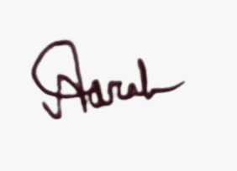
__________________
Nazah Salawat
Vice Principal
DIS, Uttara
(For Principal)

